# Computer Science SOL Development

# Sponser: CodeVA

### Department: Computer Science

#### 

#### Faculty Advisor: Dr. Budwell

#### 

#### 

#### Dr. Budwell:______________________________ Date:___________

#### Benjamin Napier:__________________________ Date:___________

#### Seth Vickers:_____________________________ Date:___________

#### Cameron Frostick:_________________________ Date:___________

#### Kenneth Richardson:_______________________ Date:___________

#### Dakota Brown:____________________________ Date:___________

# Detailed Project Abstract

Computer science SOLs are coming to VA K-12 education and teachers need to be adequately prepared to meet the standards of learning. Many teachers in K-12 education are not familiar with computer science and must be educated before they can teach computer science to their students. CodeVA, a non-profit that seeks to bring equitable computer science education to all of Virginia’s students, will prepare teachers for computer science SOLs; however, they need the tools to do so. The tools for teaching computer science must be created in order to aid the CodeVA teacher coaches, trainers who will be in charge of educating teachers in computer science. Virginia is leading the nation for K-12 computer science curriculum. It is of utmost importance that computer science education in the K-12 environment gets off on the right foot in VA because that will set the stage for computer science education standards that will be set throughout the rest of the United States.

Every teacher that is trained in how to teach computer science will be teaching a classroom with an average of 28 students. Therefore, the impact of our work will affect thousands of students throughout Virginia and, hopefully, deepen the understanding of computer science throughout the populace of Virginia. Growing demand for code literate workers in the job force is currently not being met and this project will aid in assuring that the next generation is prepared to meet the demands of the market. With a greater number of jobs being replaced by artificial intelligence and other programming techniques, it is imperative that students of today are able to understand the impact code will have on our future.

Our goal is to create Scratch programs that are accompanied by Python code and detailed documentation in order to train teachers on how to teach computer science as well as providing teachers with resources for teaching. Phase One of this project will be creating projects on Scratch Studio that are designed to teach K-5 SOLs. In Phase Two of this project, accompanying Python code will be written to reinforce the ideas taught by the Scratch programs for advanced learners transitioning from Scratch into a text-based language. Phase Two of this project will be completed by writing Python code and sharing it with the team and CodeVA through GitHub or other means. Phase Three of this project will be ensuring that every lesson taught through the Scratch and Python programs has detailed documentation that describes possible difficulties and replicates each of the teaching programs as well as describing the fundamentals of programming that are underlying each of said teaching programs. Documentation created in Phase Three will be uploaded to GitHub and other locations as specified by CodeVA. Phase Four of the project represents the stretch goals of our team. Phase Four includes expanding the grade levels for which programs are created, recording video lessons that detail each programming project, enhancing Virginia’s AP computer science program, developing after school programming club activities for middle schools, or other stretch goals as specified by CodeVA.

# Line Item Budget

The computer science department allows each capstone project a budget of $750 in order to accomplish their project. At this time, our team does not foresee our budget exceeding the original $750 budget. Dr. Dahlberg, the instructor for the computer science capstone project class, predicts that VCU will soon be getting a mainframe that should be capable of supporting any digital resources from CodeVA for the teachers in Virginia. This mainframe will be capable of providing the resources our team creates to the students, teachers, and teacher coaches of Virginia.

# Supplementary Media

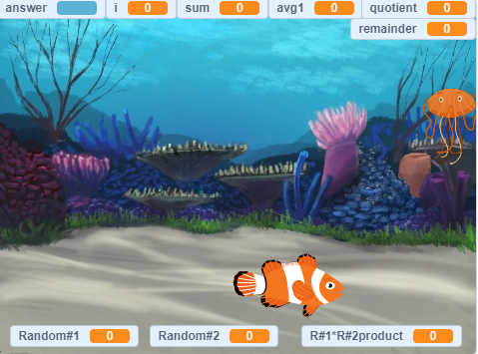

Scratch program to teach math operations with code.

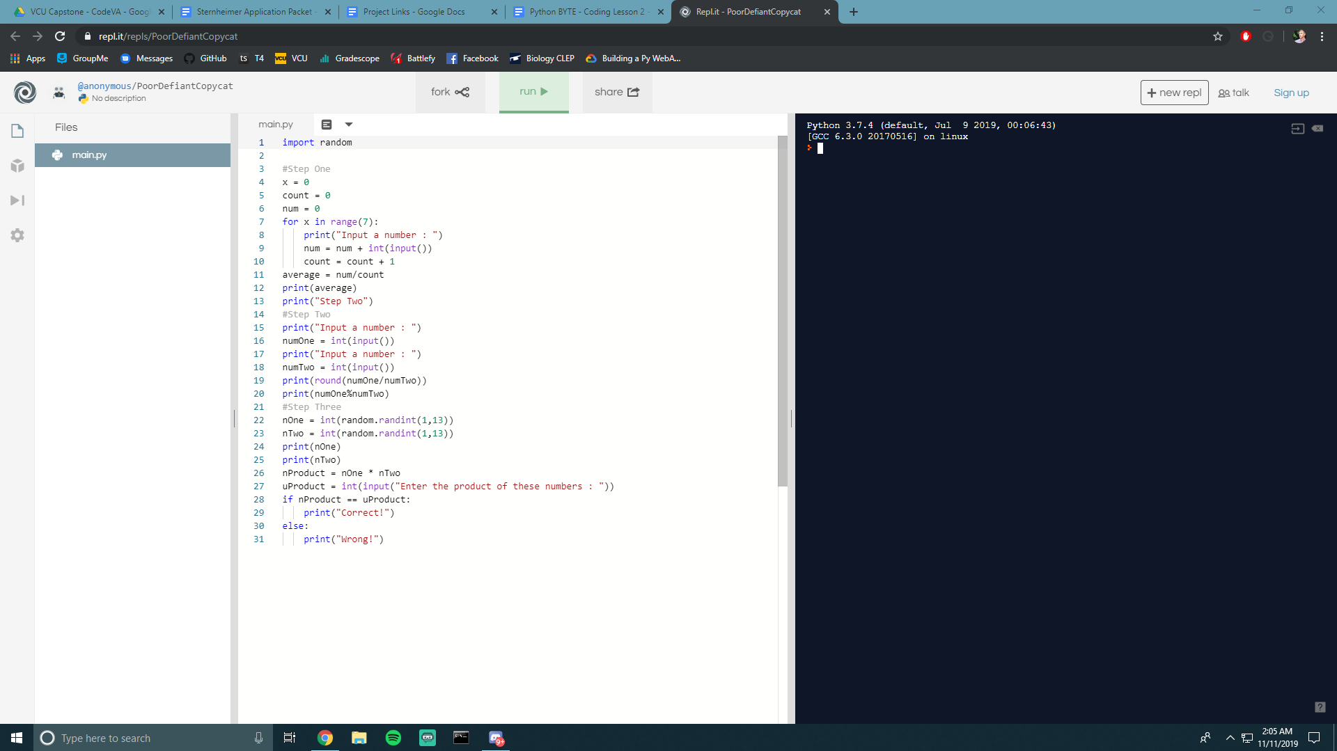

Repl.it is used to easily teach Python in a web browser.

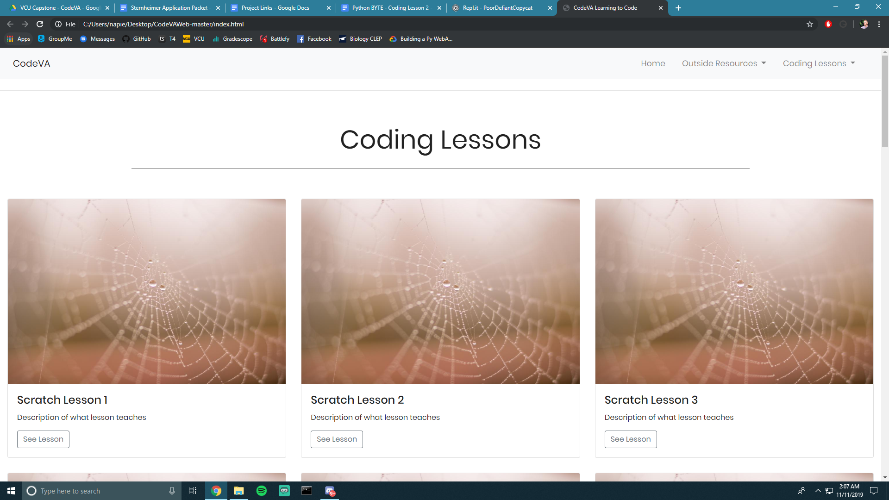

Work in progress website to collect and display computer science lessons and resources.